3D deformation of liquid crystals elastomer for small-scale structural manipulation

Mingchao ZHANG*

Department of Materials Science and Engineering, National University of Singapore, Singapore.
*zhangmc@nus.edu.sg

The three-dimensional (3D) deformation of liquid crystal elastomers (LCEs) upon thermal stimulation has been extensively explored in macroscopic applications, often seen in constructing various soft robots. However, their potential for manipulating micro-/nanoscale structures remains largely untapped. Here, we harness the spatial 3D deformation of LCEs to achieve precise and dynamic control over small-scale structures, unlocking new possibilities for microactuation. Two distinct deformation modes—planar and thickness expansion—enable innovative actuation strategies. The first approach^{[1]} exploits in-plane expansion of LCEs to drive micro-metastructures (kirigami structures), enabling programmable and reconfigurable transformations of different patterns upon heating and cooling. The second approach^{[2]} leverages out-of-plane thickness expansion, where LCEs actuate microhairs through light, mimicking artificial goosebumps. This dynamic surface control opens up exciting applications in adaptive interfaces, tunable adhesion, and high-density information storage. By demonstrating the power of LCEs’ spatial 3D deformation at micro- and nanoscales, these works establish a new paradigm for programmable small-scale structural manipulation. We believe this breakthrough will propel the development of next-generation microfluidic devices, bioinspired adaptive materials, and microscale robotics, expanding the frontiers of intelligent, multifunctional systems.

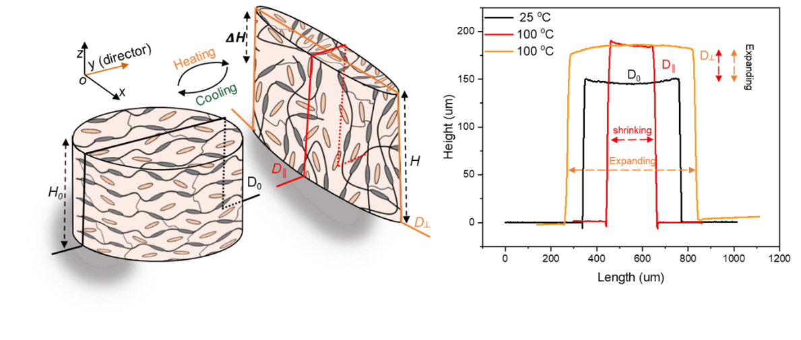
Fig.1: Schematic and profile showing the 3D deformation of liquid crystal elastomers upon heating/cooling.

References
[1] Zhang, M.#; Shahsavan, H.#; Guo, Y. #; Francesch, A.; Zhang, Y.; and Sitti, M.*, Liquid Crystal Elastomers Powering Reconfigurable Micro-Kirigami. Advanced Materials, 2021, 33 (25), 2008605.
[2] Zhang, M.; Pal, A.; Lyu, X.; Wu, Y.; Sitti, M.*, Artificial-goosebump-driven microactuation. Nature Materials, 2024, 23, 560-569.

