**Electrically switchable multi-stable liquid crystal configurations for optical applications**

**Inge Nys1,*, Jelto Neirynck1, Yu-Tung Hsiao1, Migle Stebryte1, Kristiaan Neyts2**

*1. . Liquid Crystals and Photonics, Ghent University, Technologiepark-Zwijnaarde 126, 9052 Ghent, Belgium*

*2. Hong Kong University of Science and Technology, Clear Water Bay, Kowloon, Hong Kong*

\**Corresponding author email address: Inge.Nys@UGent.be*

The alignment patterning at the confining substrates steers the self-assembly of the director in a liquid crystal (LC) cell, and post-fabrication tunability can be obtained by making use of different stimuli. In most cases, electric field application is used to tune the device properties. The response is often smooth and can be readily understood by taking into account the dielectric anisotropy of the LC. More exotic switching, including hysteresis switching or the creation of multi-stable topological states, can be obtained by using cells with well-designed anchoring patterns in combination with appropriate LC materials (e.g. chiral and/or dual frequency LC).

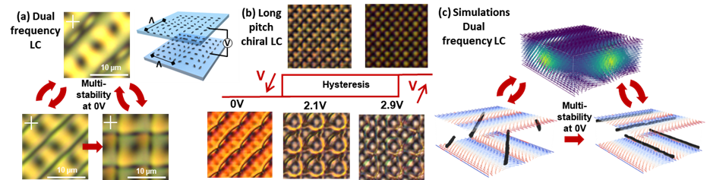

**Fig. 1** POM images of cells with crossed assembly of rotating alignment patterns: metastable states at 0V in DFNLC (a) and hysteresis switching in CLC cells (b).Simulated director configuration for DFNLC (c) corresponding to the measurements presented in (a).

In cells with crossed assembly of rotating planar alignment patterns, the surface induced frustration prevents a purely planar and defect-free configuration. Disclinations can be avoided by forming a LC superstructure with lower periodicity and localized regions with a strong out-of-plane tilt. This anchoring pattern in combination with CLC leads to the formation of two different topological states at high and low voltages, with hysteresis switching between both (Fig.1(b)).[1] By using dual frequency LC, an electrical stimulus can induce disclination lines that are preserved also without applied voltage (Fig.1(a),(c)).[2] Depending on the electric field treatment and geometrical parameters, different multi-stable states with and without disclinations can be obtained, and repeatable switching between them is realized. The observed metastability is explained by topological protection and the associated energy barrier between different states. The obtained configurations are retrieved with Q-tensor simulations (Fig. 1(c)) and the optical simulations are matched with experimentally obtained microscopy images. The realized multi-stable topological states have distinct optical properties and switching between a transparent and opaque state becomes possible by optimizing the cell geometry, LC mixture, E-field, etc. This opens up opportunities for smart windows with low energy consumption.

**Acknowledgments:** This work is funded by the research Foundation Flanders – FWO, grant number G0C2121N, Postdoc fellowship number 1257423N and PhD grant number 1SHF924N

**References:**

[1] I. Nys, B. Berteloot, K. Neyts, *Advanced Optical Materials* **10**, 23 (2022)

[2] J. Neirynck, Y.-T. Hsiao, M. Stebryte, I. Nys, *Advanced Materials* (2025)