**Multiscale approaches to light guiding in cholesteric topological patterns**

**G. Poy1,2,*, S. Žumer3,4**

*1. L2C, Univ Montpellier, CNRS, Montpellier, France*

*2. International Institute for Sustainability with Knotted Chiral Meta Matter (WPI-SKCM2),*

*Hiroshima University, Higashi-Hiroshima, Hiroshima 739-8526, Japan*

*3. Jožef Stefan Institute, Jamova cesta 39, 1000 Ljubljana, Slovenia*

*4. Faculty of Mathematics and Physics, University of Ljubljana, Jadranska 19, 1000 Ljubljana*

\**guilhem.poy@umontpellier.fr*

The past 15 years have seen the emergence of powerful experimental techniques enabling the patterning, control, and optical coupling of localized birefringent structures in liquid crystal (LC) systems. More often than not, these localized patterns of orientational order have a topological nature---they can be classified with integers similar to the genus classification of surfaces---and are stabilized by chirality---the breaking of the mirror symmetry. In particular, the concept of "topological solitons", a localized field pattern that cannot be continuously deformed into the lowest energy state of the system, is especially useful to understand the structure of these patterns. Thanks to their birefringent nature, these patterns also have strong light-matter interactions, including non-linear optical effects accessible at laser powers of a few mW and a wide array of beam shaping and guiding capabilities. Modelling the structural and optical properties of these structures can however be challenging due to the wide range of scales involved, from the ~10 nm size of singular topological defects and the wavelength size of light up to the pattern size, that can be as big as 0.1-1mm. Based on recent numerical advances allowing to adresse some of the challenges behind these multiscale and multiphysics simulations [1-4], I will present an overview of the waveguiding and optical deflection properties of nonsingular topological patterns that nature offers for free in chiral liquid crystals.

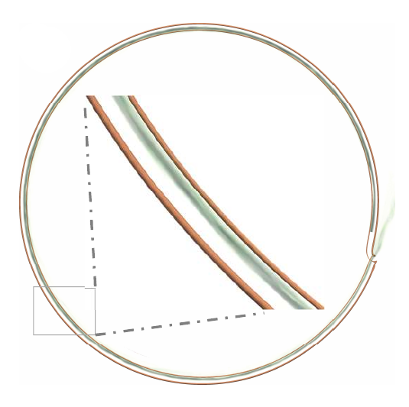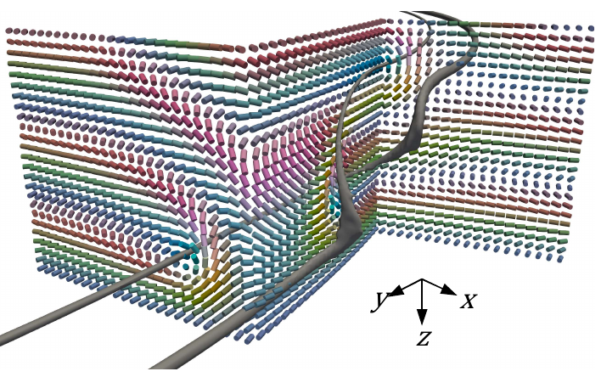

**Fig. 1** (left) Guiding light with cholesteric disclination loops. (right) Schematic of the helical layer structure near a nonsingular disclination kink.

**Acknowledgments:** G. Poy acknowledges support from the ANR (JCJC project CHIRALGHOST).

**References:**

[1] G. Poy, S. Žumer, S*oft Matter* **15**, 2659 (2019).

[2] G. Poy et al., *Physical Review X* **10**, 031042 (2020).

[3] G. Poy, S. Žumer, *Optics Express* **28**, 24327 (2020).

[4] G. Poy et al., *Nature Photonics* **16**, 454 (2022).