**Self-accumulation of polymers in a liquid-crystalline droplet under temperature gradient**

**Jun Yoshioka1,*, Hitomi Ando1 and Koji Fukao1**

*1. Department of physical sciences, Ritsumeikan University, 1-1-1 Noji-Higashi, Kusatsu, Japan*

\**j-yoshi@fc.ritsumei.ac.jp*

As seen in cleavage and differentiation of fertilized eggs, or metamorphosis of insects, living organisms form their morphologies through ordering and disordering processes at various size scales. In general, during morphogenesis, concentration gradients of biomolecules like proteins are formed in the early stages, and structural formation progresses under the influence of these gradients. Here we considered that such characteristic self-assembly phenomena might be observed also in the transition process of liquid crystalline (LC) system. In this study, dispersing fluorescent polymers into a nematic (N) LC, we created cylindrical LC droplets. During the transition from the isotropic (I) to NLC phase, the structural formation process in the droplet was observed, using polarizing microscopy (POM) and fluorescence microscopy (FM).

Keeping the sample at a sufficiently high temperature to transit into the I phase, we applied a temperature gradient (Fig.1(m)). Afterward, the sample was cooled while maintaining the gradient. As the temperature decreased, the sample transited from the I to the N phase from the lower temperature side, and a coexistence state of I+N phase was formed. Here, a cross-shaped texture was observed under POM, suggesting the presence of point defects at the droplet center (Fig. 1(b)). The point defect moved away from the center, but upon further cooling, it returned to the droplet center (Fig. 1(c)–(e)). After that, the entire I phase region eventually transitioned to the N phase, and a nematic droplet with the texture shown in Fig. 1(f) was obtained. In FM, a ring-shaped pattern appeared in the I+N phase as shown in Fig. 1(h); this indicates that the dispersed polymers in the droplet aggregated into the pattern. This ring pattern became nonuniform upon cooling, splitting into several points, and then merging into a nearly single point (Fig. 1(i) and (j)). In the regions of the polymer aggregation, the director field with the cross-shaped texture was modulated (red arrows in Fig. 1(c), (d), (i), (j)). On further cooling, the aggregated polymers gradually diffused throughout the entire droplet (Fig. 1(k), (l)).

Moreover, measuring the flow field inside the droplet, we found that strong Marangoni convection occurred in the I+N phase, and that a characteristic flow field was generated around the points where the polymers aggregated. It is considered that the anisotropic viscous dissipation induced by these flows in LC results in the characteristic aggregation phenomenon.

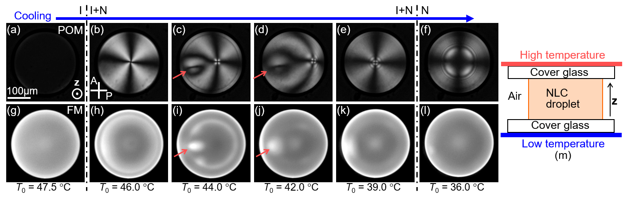

**Fig. 1** Structure formation of NLC droplet. (a)–(f) are POM images, and (g)–(l) are FM images at each temperature. *T*0 is averaged temperature inside the droplet. (m) is a schematic image of experimental set-up.