**Designing polar topology in ferroelectric nematic liquid crystals for nonlinear photonics**

**Satoshi Aya1,*, Yu Zou1, Jidan Yang1, Ze-Ning Hong2, Qi-Huo Wei2**

*1. South China Advanced Institute for Soft Matter Science and Technology (AISMST), School of Emergent Soft Matter, South China University of Technology, Guangzhou 510640, China.*

*2. Department of Mechanical and Energy Engineering, Southern University of Science and Technology, Shenzhen, 518055, China.*

\**Corresponding author email address: satoshiaya@scut.edu.cn*

Complex polar topological configurations are the foundation for exploring exotic phases and nontrivial emergent phenomena in condensed-matter physics. While numerous topological configurations like skyrmions and merons are known to occur spontaneously in various materials, achieving the designability of magnetically- and electrically-polar patterns textures in a controlled manner is a long-standing challenge in domain engineering.

Ferroelectric nematic liquid crystals are new classes of liquid crystal states with a spontaneous polar field [1]. In contrast to the traditional nematic liquid crystals that are apolar, the inversion symmetry is broken in the ferroelectric nematic liquid crystalline state. The new state offers us an unprecedented opportunity to design and control polar topology [2], setting a platform of domain engineering in liquid-matter systems, which, in turn, provides numerous possibilities for developing novel, advanced, flexible optoelectronic devices. In this presentation, we report large-scale domain engineering with various polar designs at microscales through spatial confinements, which has been impossible in solid-state ferroelectrics in terms of design flexibility and reconfigurability. The designability of polar fields enables the development of nonlinear photonic devices onto a liquid-crystal-based chip.

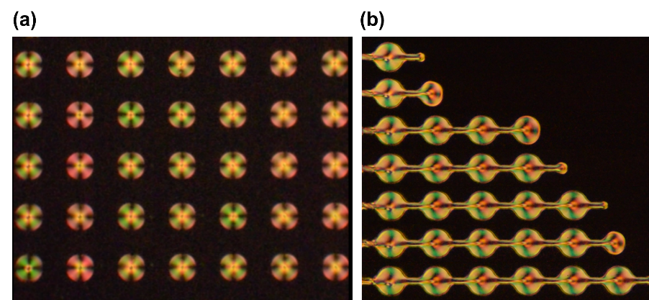

**Fig. 1** Controlled polar toplogy by designing **(a)** micropores and **(b)** microchannels.

**Acknowledgments:** This work was funded by the National Key Research and Development Program of China (No. 2022YFA1405000).

**References:**

[1] N. Sebastián, M. Copic, A. Mertelj, *Phys. Rev. E* **106**, 021001 (2022).

[2] Y. Song, S. Aya, M. Huang, *Giant* **19**, 100318 (2024).